**The nuclear leap to outer space**

Mankind’s curiosity to know what secrets lie hidden in the dark outer space is not new. From the invention of the very first telescope in the 17th century to the present-day space exploration programmes, man has always been keen to discover the treasures concealed by our galaxy - the Milky Way and beyond. This eagerness has fuelled research and development efforts towards rockets and satellites since the 1957 launch of the first Soviet artificial satellite "Sputnik 1" into the outer space.

Artificial satellites are crucial to space exploration missions as they serve many purposes ranging from the collection of Earth's meteorological data to the observation of distant planets, galaxies, and other outer space objects. To function uninterruptedly, they need an independent power source - the farther the horizon, the greater is the need for a sustainable power source. A space exploration mission requires power at many stages. From the initial launch of the space vehicle to the functioning of instrumentation and communication systems and the heating/cooling of vital systems, a power source is essential to carry out various tasks during such missions. To this date, most satellite launches use combustion techniques (<https://www.grc.nasa.gov/WWW/K-12/rocket/rocket.html>) during launches and many satellites use solar panels to convert sunlight into electricity, making it a common method for energy generation. However, since the intensity of sunlight decreases with increasing distance from the sun, the use of solar panels is impractical for farther space missions.

With these considerations in mind, alternate sources for power generation that are independent of solar energy were sought. One of these alternatives employed the energy generated from nuclear resources. There are two known ways to harvest this energy, depending on the required level of power supply:

1. **­**[**Radioisotope Thermoelectric Generators (RTGs):**](https://en.wikipedia.org/wiki/Radioisotope_thermoelectric_generator)used for small power requirements (up to 5kW), the RTGs work on a simple principle of converting the decay heat released from the radioactive isotopes into electrical energy. The most widely used fuel candidate for these RTGs is the radioactive isotope Plutonium-238. Being an unstable atom, Pu-238 loses energy to reach a stable stage. To achieve this, the Pu-238 atom is bombarded by a high energy neutron, causing it to split and release alpha particles (see <https://opentextbc.ca/chemistry/chapter/21-3-radioactive-decay/> for more information about radioactive decay). The energy released from this process is then converted into electricity.

Since RTGs have no moving parts, they are very reliable and continues for as long as the radioisotope source produces a useful level of energy. RTGs have been used to power various space exploration missions such as [Pioneer-10](https://en.wikipedia.org/wiki/Pioneer_10), [Pioneer-11](https://en.wikipedia.org/wiki/Pioneer_11), [Voyager-1](https://en.wikipedia.org/wiki/Voyager_1), [Voyager- 2](https://en.wikipedia.org/wiki/Voyager_2), [Galileo](https://en.wikipedia.org/wiki/Galileo_probe), [Cassini](https://en.wikipedia.org/wiki/Cassini-Huygens), and the [Mars Science Laboratory](https://en.wikipedia.org/wiki/Mars_Science_Laboratory" \l "Power_source).  Also recently, the US Department of Energy has delivered a Multi-Mission RTG (MMRTG), which is to be used for powering the Perseverance Rover of NASA's [Mars 2020](https://mars.nasa.gov/mars2020/) mission.

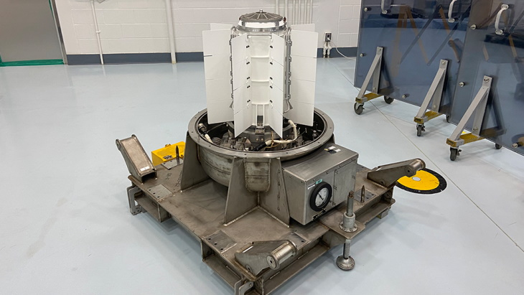

The Multi-Mission Radioisotope Thermoelectric Generator (source: US Department of Energy (DOE))

1. **Fission Reactor Systems in Space:** While RTGs are the ideal choice for long term space missions requiring low power functions, when it comes to higher power requirements (above 10kW), fission power systems (FPS) have a distinct cost advantage over RTGs. The designs for these fission reactor systems have been derived from the existing designs of the terrestrial [liquid metal cooled fast reactors](https://en.wikipedia.org/wiki/Liquid_metal_cooled_reactor), with adjustments made for the reactor system to function in a zero-gravity environment as required in a spacecraft. The earliest examples of the use of fission reactor systems includes the 1965 [SNAP-10A](https://en.wikipedia.org/wiki/SNAP-10A) probe launched by the USA and the Soviet/Russian developed [TOPAZ reactors](https://en.wikipedia.org/wiki/TOPAZ_nuclear_reactor).

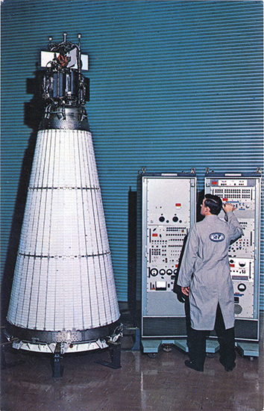

[Image of SNAP 10A Space Nuclear Power Plant](https://en.wikipedia.org/wiki/SNAP-10A" \l "/media/File:SNAP_10A_Space_Nuclear_Power_Plant.jpg)

In addition to these power sources, nuclear energy can also be harnessed to drive [spacecraft propulsion](https://en.wikipedia.org/wiki/Nuclear_propulsion). Thus, it's clear that the use of nuclear energy can dramatically change the capabilities of interplanetary spacecraft. The distinct advantages of nuclear sources over conventional power sources such as long duration sustainability, energy efficiency and compactness make them the perfect choice for future space exploration missions.

**References:**

1. <https://en.wikipedia.org/wiki/Nuclear_power_in_space>
2. <https://world-nuclear-news.org/Articles/Nuclear-power-system-delivered-for-Mars-rover-laun>
3. <https://www.world-nuclear.org/information-library/non-power-nuclear-applications/transport/nuclear-reactors-for-space.aspx>
4. IAEA Publication : [“The Role of Nuclear Power and Nuclear Propulsion in the Peaceful Exploration of Space”](https://www-pub.iaea.org/MTCD/Publications/PDF/Pub1197_web.pdf)